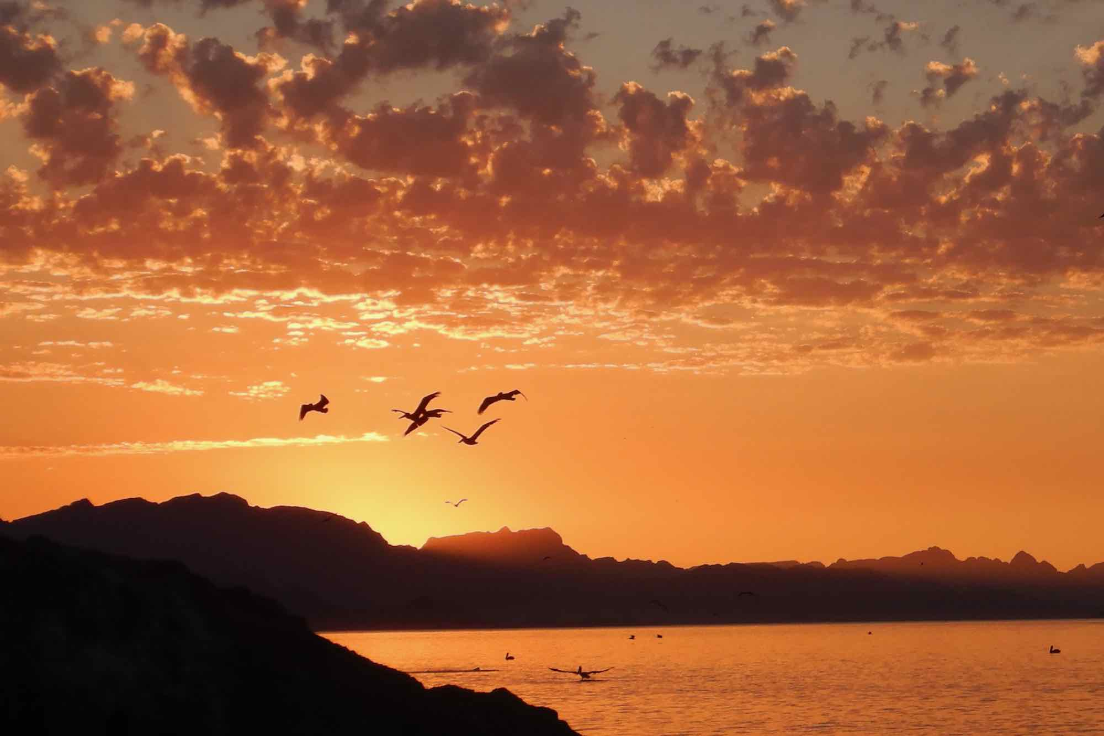 | Journey at the Edge of Desert  and Sea:  A sea kayak,  camping,  dreaming,  soul listening pilgrimage in  Baja, Mexico.  Nov. 11-15, 2026  $2000  If interested contact  Karla Woggon, soulsauntering@gmail.com
This pilgrimage is a slow journey along Baja’s desert–sea edge, where salt and stone conspire to wake the deeper self. Each day we paddle close to shore, reading tides, wind, and light. Each evening, we gather for dream work, soul reflection, ritual, and shared listening. Nights are spent camping under a vast, star-filled sky. This is not about self-improvement, but soul awakening. We listen for the soul as it speaks through image, dream, longing, ache, and sudden delight. The wildness of the sea serves as our soul guide.
What Shapes the Journey
- Sea Kayak as Threshold Practice – Slow the nervous system, sharpen perception through paddle, water, and wind.
- Jungian-Informed Dream Work– Honor image and mystery as we listen for the soul’s longing in group dream work.
- Soul Work in a Thin Place – Guided reflection and nature-based practices for deep belonging.
- Ritual, Silence, and Story – Evenings shaped by simple ritual, shared meals, and spacious quiet.
- Camping by the Sea – Simple camping on the shore, in the holy liminal space where land and sea meet.
- Is This Journey for You?
- You sense a threshold season in your life
- You are drawn to dreamwork and nature-based spirituality
- You long for a journey where landscape and soul speak together

What’s Included:  - Kayaks  - Guides: Sea Kayak Wilderness guide, and Spiritual/Soul guide,  - All meals while on the expedition  - Wilderness permits. | What’s Not Included  - Lodging in Loreto (one night before and one night after the expedition)  - Airport transportation  - Meals in town  - Tips for kayak guides: recommendation is $400  - Camping Gear – available for rent

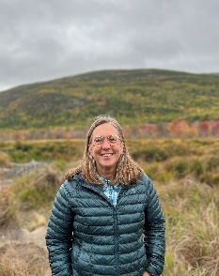 | Soul Guide: Karla Woggon a retired Episcopal Priest and seasoned  spiritual director, dream worker, pilgrimage leader, and lover of stories. Karla has over 30 years of experience listening for the wisdom of the soul and the presence of the Divine incarnate in all of creation. She is the director of Soul Sauntering, LLC

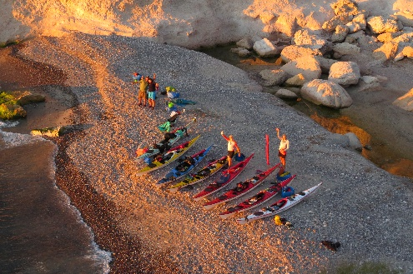 | Sea Kayak Guides: https://www.seakayakbajamexico.com/  Ginni Callahan, Founder & Guide with Sea Kayak Baja. After nearly a decade leading big-group “no experience needed” trips around Loreto, Ginni took a leap in 2007 and started Sea Kayak Baja Mexico to do things differently. Along with expert paddling, she loves sharing her knowledge of desert plants, marine life, geology, and the night sky — bringing Baja’s wild beauty to life for every guest.

